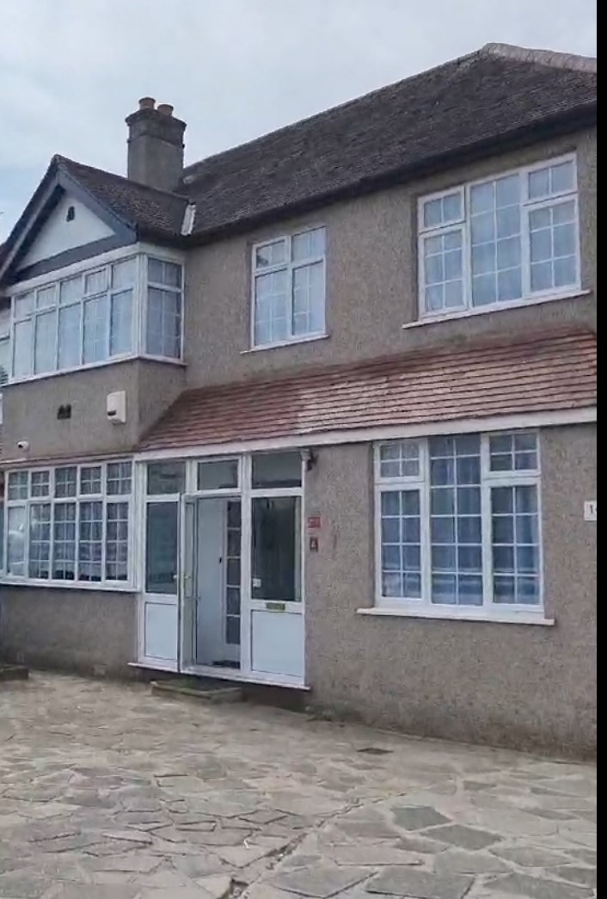

STATEMENT OF PURPOSE
FOR
14 OAK AVENUE, CR0 8EE
SUPPORTED LIVING 18 -25 YEARS
SEMI-INDEPENDENT LIVING 16 -18 YEARS
Introduction
Oak Avenue Home (5-bedroom house ) is an accommodation being provided by Josak Care and recruitment ltd, to accommodate 4 looked after-young people and care leavers to help them develop their independence as they approach adulthood, ahead of leaving the care system. Our supported accommodation is in a shared living situation on premises which is not limited to accommodating looked after young people and care leavers. In addition to being registered to support looked-after young people and care leavers aged 16 -18 and floating support for 18-25 years, this provision also provides accommodation for people who are not looked after young people or care leavers.
We carry out location assessments in order to provide young people with property in ideally placed locations close to many amenities, shops, reputable schools and green spaces. Our Supported Accommodation reflects the 8 key principles echoed by Young People in “The Supported Accommodation (England) Regulations 2023 (the Regulations)” below:
- I feel safe and secure where I live and in my wider environment.
- My voice is respected, heard and advocated for, so I can influence the support I receive.
- I have confidence that the adults who support me understand me, are skilled and work effectively together to best meet my needs.
- I have my own space that I feel proud of and live in a comfortable, well-maintained, and stable accommodation.
- I receive high-quality, tailored support that sustains my health and well-being.
- I have strong, trusting, and meaningful relationships within my support system and can rely on the adults around me.
- I feel supported to learn and apply skills for independent adult living.
- I feel positive about my future and opportunities as a result of the support I receive.
At Josak, our service is centred on our slogan ‘Your Satisfaction Our Priority’. To ensure we achieve this our service is based on Person-Centred Care as we provide affordable care and support to an entirely young people-focused approach. Our ethos is very much to provide a safe and secure environment for the young people in our care and to offer and bring them much-needed stability, in what could potentially be a turbulent period of their lives due to several factors, and we make no judgements.
We recognise that their needs will be challenging and offer a listening ear and an open mind and give them the opportunity to voice their concerns, a process which might be new to them. We do not want them to feel lost, despaired or hopeless; we want them to value the importance of their place in society and to encourage them to take steps that will benefit them in all aspects of their life. Our accommodation act as anchors where they can feel in control of their environment, empowered, and engage in social and recreational activities alongside a structured approach, guiding them to live a positive and enriched life. Every young people matters to us and, while we do not condone or, tolerate negative and derogatory behaviours, we are unconditional in our acceptance of every young person.
Aims and objectives
Our overarching ethos is to work in collaboration with key people to sustain links and understand past problems, in order to help and support young people to reach their full potential and to prepare them for their future lives. We recognise that each young person is an individual who will have unique needs and aspirations. This forms the basis for all of our person-centred activities and is at the very heart of what we do and what we stand for throughout our supported accommodation.
We want to play a role in helping to develop them; to nurture and to foster their optimum health and wellbeing, to empower them to see the options available to them, to provide a stable and secure environment and understand
that they can achieve their hopes and dreams. We aim to do this in a variety of ways:
- We aim to forge a trusting and solid rapport, giving them a comforting and caring home
- We want to equip them with the necessary emotional, mental and practical tools to take away and instil a sense of self-worth and belief
- We encourage them to feel part of a family set-up
- We work closely with them to develop and maintain effective strategies to deal with their problems
- We empower them to take responsibility for their past actions
- We encourage them to focus on what they would like out of their future and to identify steps on how they can get there
- We aim to boost self-esteem, confidence and worth
- We act to repair earlier damage to their confidence and self-esteem
- We encourage making positive and meaningful friendships
- We always reinforce positive behaviour and actions
- We allow them to be very much part of an informed process and they have every chance to voice their opinions and have their say
- A major focus is on our mentoring programme which we encourage active participation in
- We have positive role models from all walks of life (all DBS-checked) visit the supported accommodation to give informal talks regarding potential future career pathways
- We will, wherever possible, facilitate positive and constructive experiences, which we believe will have a beneficial impact on the young people
- We offer opportunities for hobbies and other creative outlets
- Through regular mentoring meetings we will measure the effectiveness and success of the mentoring programme, and work to overcome any barriers, issues, and to encourage any positive progress made
- Through legislated policies and procedures, we will govern the supported accommodation to the best of our capabilities
- Our cohort of expertly trained staff will act as guardians of the supported accommodation and of the young people, always making themselves available, and play a significant part in their progress during their time with us
- We will regularly review and, if appropriate, update and amend existing documentation and paperwork to ensure it is fit for purpose always and is in accordance with law and legislation

Choice, Respect, Privacy, Independence and Dignity.
We recognise that each young people is entitled to have a choice, respect, privacy, independence and dignity.
Choice
Each young person is encouraged to make decisions regarding their own bedroom and to make it their own.
Each young person is encouraged to take part in activities and to make informed choices about all aspects of their lives.

Respect
Each young person is given respect, but it is made clear that it has to be mutual and that respect is returned, and that all staff are treated correctly and appropriately by the young person.
Privacy
Young people have their own bedroom.
Every young person receives sensitivity in practice, particularly when dealing with personal issues or problems.
All information regarding the young person will remain confidential and will only be shared when it is deemed necessary and appropriate.
The young people’s designated areas will not be used for the purpose of staff meetings or for visitors, so they will not feel as if their personal space is being encroached upon.
Independence
Our supported accommodation provides an arena which seek to aid personal development and boost self-confidence by allowing the young people to take some calculated risks over the course of their learning journey with us, and to understand how they may be expected to continue to take such risks in their later life, and how to deal with that process.
Each young person has access to their own personal file and development plans and are encouraged to input as much as possible.
The young people know the correct and comprehensive way to make a complaint, should they need to do so.
Access to an independent advocacy service is available and the young people know exactly how to make contact.
Dignity
All staff have an active awareness of young people’s racial, cultural, religious and dietary needs, promoting and celebrating difference.
We use behavioural management techniques to reprimand negative behaviour, avoiding punitive measures, in a way in which the young people can learn from their mistakes, and from positive role models within the supported accommodation.
Our supported accommodation
When seeking out ideal locations for our properties, we deliberately identify dwellings near good schools. We forge productive and effective relationships with local schools in order to provide the optimum education package for every young people and review annual Ofsted reports for all relevant academic establishments.
We look at areas which have a community ‘heart’ as we feel it is imperative to set a good example to the young people and engage them as much as possible within the local communities and instil a sense of belonging.
We try and have properties, where possible, close to green spaces and scenery which will help enhance the young people’s mental and physical holistic well-being. In addition, we endeavour to locate spots where amenities are close and there are good public transport links, allowing the young people to be able to travel and be independent, if appropriate.
All supported accommodations are furnished, decorated and maintained to the highest standard.
Each home is an extension of our brand and will be the first thing a young person sees when they come to stay with us, so must encompass our ethos and match our brand identity.
Equality, Diversity and Inclusivity
Josak views the needs of each young person as paramount and of being of upmost importance. We demonstrate understanding, sensitivity and awareness to all.
We encourage young people to respect themselves as well as others. Our services are aimed to develop the young person, regardless of their ethnicity, culture, age, religion, ability, background and sexual orientation, to assist them
to reach their full potential.
We regularly review our placement criteria so that the young people who are offered a place in our supported accommodation are treated and selected on the basis of their individual needs and abilities. Any special assistance will be given to them if required. If a young person has a particular faith, then this will also be treated with the utmost respect. Josak works with all local faiths and places of worship to ensure that there is a sustained and effective relationship with them. The young people are informed where their closest religious services are conducted and encouraged to maintain attendance. We always pay attention to their cultural or, religious beliefs and needs and do our best to make sure the link is not broken, and that they continue to develop their faith.
Some of the ways in which we promote cultural identity are by:
• Promoting that identity and giving positive images and examples of that identity
• To fully prepare young people to grow up in society
• To learn about the young people’s culture, to encourage that young person to share their experiences, and to guide us on how best to engage with their cultural identity on a day-to-day basis – for example, personal care, customs
• The young people have every opportunity to update their personal records and development plans with insight into their identity so that staff can familiarise themselves with this and know how to act.
• Learning about specific dietary requirements and making sure they are adhered to
• Staff will endeavour to conduct their own research into that young people’s heritage and customs
• Staff undergo appropriate training on equality, diversity and inclusivity to make sure their knowledge is up-to-date and evolving
• Staff are always mindful of using language which may have negative connotations for the young people
• No staff will ever attempt to enforce their own opinions on any young people, relating to culture, religion, etc
For more information, please refer to our Equality, Diversity and Inclusivity Policy.
If you have a complaint
We have a clear Complaints Policy. If anyone displays any worrying concerns or issues relating to their care and support, then we will actively encourage them to use our Complaints Policy.
Upon arriving at our supported accommodation, all young people and families, social workers, and their advocates will be notified of the complaints procedure and how to initiate the process. They will know exactly how to proceed, all of the stages involved and who they can go to, if they have any problems.
Complaints can be dealt with formally or informally. In the case of an informal complaint, every effort will be made to resolve the issue with a satisfactory outcome for all parties involved. Our formal process is activated if it cannot be
resolved informally and will be investigated independently. Josak will remain transparent throughout this process.
All complaints are taken with the utmost seriousness and the young people will never be left to feel like their concern is not big enough or, that it is not important enough. This is reiterated to them throughout their stay in our supported accommodation.
The policy is always accessible on site and a young person-friendly version can be made available.
Views, wishes and feelings of the young people
How do we consult the young people
The young people are entitled to have a say regarding every aspect of their care at our supported accommodation. We believe they should be encouraged and supported to make decisions and to influence decisions about how the supported accommodation is run.
We assume that all young people under our care can make informed decisions unless we are told otherwise. With this in mind, we actively seek their opinions relating to themselves and that of the supported accommodation. We welcome feedback from them, as it helps steer us and the way in which we might operate in the future.
We appoint a key worker to each young people and that key worker works closely with them and acts as their advocate. The key worker regularly reviews and monitors their progress and, as part of this process, asks the young people’s opinions and views. This is all taken into account and relayed to the home manager.
They all have the right to air their views and we support them to feel confident enough to express themselves and help them if they are unable to. We expect them to have an understanding and appreciation of the rules of conduct and
what is deemed inappropriate behaviour.
The opinions, views and suggestions of their families, guardians, and social workers are sought on a regular basis, whether it is written or verbal feedback.
We consult the young people by:
• Holding regular meetings where everyone has the opportunity to make suggestions and contribute. Prior to these meetings, the young people are encouraged to take a lead role in setting the meeting agenda
• Seeking their views and opinions in a variety of ways so that the young people feel comfortable and safe expressing them. For example, conducted via one-to-one, a meeting, written down anonymously, questionnaires, or quality audits
• Making them aware that they always have an opportunity to speak their mind, and to come forward if they wish to do so
• If appropriate, the young people will receive either a verbal or written report from what is discussed in staff meetings, if the discussions have any implications for them
• If a young people is struggling to express their views or, voice their concerns, we use advocates to act on their behalf
While staff will be responsible for taking notes at these meetings, the young people will take the lead in setting the agendas. A summary of the meetings will also be kept in the young people’s file, which the young people will be able to access at any time.
We do not judge and guide young people not to judge and to be tolerant of everybody’s beliefs, faith and attitudes. We actively challenge any type of discrimination.
Education
Josak promotes a learning environment and actively supports young people’s development. We work with local authorities to make sure that each young people is placed appropriately and according to their needs. Any previous placements will be taken into consideration, as will any special educational needs or disabilities (SEND). If there are such needs, then we will engage with the school’s SEN representative to make sure that the young people’s needs are fully being addressed, and they are wholly supported.
Josak believes that no young people should be academically disadvantaged and completely understand that the young people in our care may have undergone negative experiences; they may have been left without any education at all or as a result, have suffered with low self-esteem or confidence. We make every effort to that these are key factors when referring and working with educational authorities. We put proactive education and learning plans in place for the good of the young people and to harness a positive scenario whilst they are of school age.
Josak is well associated with surrounding schools and maintains an accurate and up-to-date list of all the schools that are available, pertinent contacts, locations and facilities, and whether they have specialist services. We make every effort to ensure that the young people does not miss out of their education.
We do not condone anyone missing school and, if this is brought to our attention, we immediately seek to identify reasons why, and how we can best solve any concerns and problems. This will be done with the staff here, the young people and the school in question.
Josak aims to develop a close working relationship with the young people and puts into place a mutually agreed learning plan and contract so that the young people know full well what the expectations are of attending school and what they will need to do. We oversee their learning and it is our focus to support them to reach their academic goals and maximise their achievements while acting quickly to overturn any potential underachievement. We value their education and have an Education and Learning Policy.
As young people near the end of school, we always discuss future options with the young people to identify what path they wish to take. We liaise on their behalf, if necessary, with local job centres, training providers, further education colleges, etc, and support them make a successful and seamless transition between full-time education and whatever path they may want to pursue. We give them as much knowledge as possible about the support systems in place and what they can access to provide them with those opportunities.
We have a collaborative approach to furnish these young adults with the skills and tools to enter adulthood and support and guide them to make positive and lasting impressions on potential training providers, colleges, or job centres.
Each young person’s keyworker has the responsibility of discussing the young people’s schooling and education on a regular one-to-one basis; in conjunction with Education Training and Employment Officers(ETE), and teachers when required. If any young people are excluded from their school, we make sure appropriate education and training is place, so that their education does not suffer. We will make arrangements for them to be educated until their full-time education can be resumed.
We praise educational achievements whenever we can to instil confidence and belief in their ability, and we recognise and highlight good behaviour at school.
Enjoyment and achievement
We are very proactive in ensuring that young people enjoy a varied programme of recreational and physical activities at our supported accommodation. Recreational facilities are made available to all, as is appropriate to their individual needs. The staff encourage the young people to experience and try a variety of hobbies and creative pursuits. We want to make sure that they develop emotional, intellectual, creative, social and physical skills through a bespoke programme. We listen to what they want and if it is possible, we will give them the chance to indulge.
Our accommodation has a large lounge with a dining area where the young people have access to various Freeview/Netflix Television channels, and PS5 consoles. There are laptops and a computer with internet access for young people to complete school assignments. Also, the kitchen facilities have a big fridge/freezer for young people to store their food.
We encourage trips and outings and if we can combine an educational or cultural aspect then we will. We encourage the young people to diarise their trips and to take photographs and highlight what they have learned about. Prior to outings, staff conduct a risk assessment, just to check that no issues or difficulties will be encountered, and protocols are in place.
Young people take part in age-appropriate activities as agreed with staff in a way similar to how a reasonable parent might reach an agreement with their young people. This underpins our activity and recreation programme.
An interest shown in other pursuits will always be recognised. Any engagement with local charities and organisations which enable young people to make positive contributions to the wider community will be encouraged.
This will broaden the experiences of the young people, teach them about life and what goes on in the wider world. We also encourage them to make friends outside of the home set-up. This could result in their friends visiting, or vice versa, and we have procedures in place to make sure visits are structured, without taking the enjoyment out of it for the young people. If they wish to stay overnight at a friend’s home, like any reasonable parent we will work in conjunction with their friend’s parents or guardians to make it an enjoyable and risk-free experience.
All young people will be given the opportunity to take part in an annual holiday organised by the home they reside in. This will normally be within Britain and will be arranged according to the young people’s needs.
We feel our staff are best placed to know what is in the best interests of the young people and can independently make decisions on which activities are undertaken. When they arrive, they are asked to fill out a form detailing their likes and dislikes, what they like doing, hobbies, personal arrangements such as trips to the hairdressers, etc. This is updated as and when so the information is always live and current.
We try and guide them to learn skills which will be useful for them later in life and to make it a fun learning process. An example of this is, we offer to help them learn how to cook simple things. This also gives the young people a sense of achievement and reward, and they are encouraged to share what skills they have acquired.
Health and well-being, Food and Nutrition
We know and appreciate the importance of the health and well-being of every young people and are always working hard to improve their quality of life and promote their independence. We make sure their physical, emotional and health needs are met at all times, and give expert guidance, advice and support on health and personal care issues.
We work in partnership with parents, guardians, social workers, and others to ensure that every young people is registered with a local GP, dentist and optician and that arrangements are made for visits.
It is key to us that young people are responsible for understanding their own personal health needs and make every effort to do things which promote positive health. They have a say in what those needs may be and these are noted down explicitly in the support or care plan.
If the young people take medication, trained staff administer it correctly and make sure prescriptions are topped up. We obtain the correct consent from either their parents or guardians, so we have the control of giving it to them. We teach them about why it is that they need to take it, in a way that they will understand and how important it is to their optimal health.
If it is appropriate we will include them in any discussions around changing or managing the dose. Any decisions about who will be responsible for administering or consenting to emergency medical treatment will be taken after consultations with relevant medical professionals and those with parental or guardian responsibility. All medication is stored in a secure and locked cabinet and stringently monitored daily, and all details are recorded and counter-signed.
Young people at the supported accommodation can access specialist services, such as Sexual Health, sports activities etc, and we work with a local counselling agency if we need to make any referrals to their counselling service.
Our staff training programme is constantly reviewed by the home managers to ensure that we are being trained in all the right areas relating to health and well-being, so we can care for them in the way in which they deserve to be cared for. It is our job to make that happen, so they can come to us any time with any issue, confident that we will do the best for them. We have a listening ear and an open mind, and we do not want them to feel awkward or embarrassed.
We hold regular informal talks around all aspects of health and well-being and often invite people to take about health-related topics. The staff will sit in with them if appropriate because we want to enhance their knowledge as much as we can, in addition to enhancing the awareness of the young people. This is important if they have any questions afterwards and they do not feel they can be open around strangers; they know they can come and talk to us to clarify anything they were not sure of.
We try and equip them with life skills for when they leave us and enter the world of being an adult. We teach them about self-confidence, belief and awareness, how to conduct and present themselves, and personal hygiene.
At the supported accommodation we encourage Young People to eat a healthy diet and staff sits and eat with them in the dining area. Each week, staff supports young people in do a shopping list using their weekly allowance.
Positive relationships
We want young people to make sound and lasting positive friendships and relationships, to interact correctly and to display positive behaviour. We work with the social workers to maximise opportunities and experiences so that, they get the best out of being here and that it will have a lasting impact on their lives. Social workers will maintain regular contact both through us and directly with the young people via visits and telephone calls. Our staff help to encourage them to liaise with their social worker and to attend all meetings involving decisions about their future.
We do not like to put any form of restriction on the number of visits or calls that are made with the social worker; we can never say for sure how much help and support will be needed and want them to feel they are free to contact them whenever they like. Copies of any incidents or, reports are forwarded to the social worker.
All the relevant parties, whether they are social workers, parents or guardians are encouraged by us to take a keen interest and involvement with their young people’s life, welfare and care. Obviously, this varies with individual cases and there may be some situations where young people do not want to make contact with parents, guardians and significant others, and vice versa. When that happens, our focus is always on the young people – to make them feel as loved, wanted and valued as possible.
It is our policy to actively facilitate these contacts. In appropriate cases, parents or guardians are encouraged to attend reviews and all relevant parties are informed of any decisions or developments, which may occur.
The supported accommodation provides young people with access to a telephone line, email and post at reasonable times and following an appropriate risk assessment, undertaken with the key people responsible for that young people’s care.
Parents and guardians are always welcome to visit. However, it is advisable to notify staff of intended visits, this allows for a proper period of preparation and planning. We do not want young people to feel under pressure or, anxious at all, so this is always at the forefront when we plan ahead like this.
At the supported accommodation we do not condone bullying of any nature, whether it is staff or young people-related. We have a strong zero-tolerance policy, outlined in our Ant-Bullying Policy.
We talk to the young people about what is acceptable and unacceptable behaviour and make sure that they fully understand what is right and what is wrong. If they do not act appropriately, we hold them accountable and work with them to realise why they have acted in the wrong way, and how they can resolve the situation.
We are very open and encourage any of the young people to come and talk to us if they feel threatened or bullied, and we act immediately to resolve it. We work with young people to make them aware that any sanctions for bad behaviour are fair and justified.
We encourage young people to develop skills that will enhance the relationships they have and will encounter throughout their lives, to build positive relationships and how to talk openly if they are ever faced with any conflict.
Safeguarding our young people
Josak works in effective partnership with local authorities and police, in relation to Young people Protection and Safeguarding procedures. The policies and procedures are written and used collaboratively with the local authority and Josak, which ensures that they are accessible and familiar to all the care staff team.
We have incredibly robust and stringent policies around the protection of our young people, many of whom we believe to be highly vulnerable. We want every young people to feel secure, safe, and free from harm, abuse, neglect, and accidents.
All of our supported accommodations are kept as secure as possible, to the best of our ability. We conduct extensive research into both the immediate area and areas slightly further afield of all of our locations. We regularly engage with the local police about any suspected or, reported crimes in the locality and make sure we act accordingly to make the home as safe as possible.
Staff are on duty during the day and at night and 24 hours CCTV monitor the placement 24 hours a day, 7 days a week, 365 days a year. When the manager is not present, staff will have access to contact them if a situation arises. Also, we have in place a fire alarm system (tested weekly), with no smoking signs inside the building as we have a designated smoking area outside the property.
Our home managers have a direct responsibility to ensure that every single incident that involves some level of harm or, danger to any of the young people in our care, is treated swiftly and promptly and reported to the local EDT (Emergency Duty Team). This includes situations that take place away from the supported accommodation.
The staff encourage the young people to be as open and honest as possible and how to recognise potentially alarming signs, that they need to report to a member of staff right away, and to not feel unable to speak out.
Bullying of any nature is never tolerated under any circumstances and all staff remain constantly vigilant in respect of bullying. Young people living at our supported accommodation may be extremely vulnerable and sensitive to bullying, due to past experiences in their lives and many others will bully other young people as a means of protecting themselves.
All cases of bullying are reported to LADO (Local Authority Designated Officer) because it is our policy to notify the local authority, who will either offer us advice or, take action to intervene in extreme cases. Ofsted will also be informed.
Staff regularly undertake risk assessments where incidents of bullying are evident or suspected and take every step to halt any acts of bullying. The supported accommodation accepts responsibility for every young people in its care and will respond immediately to any situation, for the welfare and wellbeing of the young people.
Support plans are in place for every young people and these are kept up-to-date at all times. It is our responsibility to record anything that has happened with regards to protection and safeguarding and we are a highly transparent company in that respect. Our extensive Safeguarding Policy outlines all of our protocols and procedures.
We treat very seriously any young people that go missing from our care and have a detailed protocol with a series of escalating actions geared towards that young person returning home safe and well. Where we know of a history of young people going missing, we attempt to take necessary preventative steps to make sure they do not go missing, and to identify any red flags relating to that young people’s behaviour, which could suggest this is something they are thinking about or, actively planning.
As well as contained within this document, our safeguarding and missing-from-home policies can be viewed upon request and are also kept in a separate folder with all of our existing policies and procedures.
The majority of our referrals come from social workers. Whenever possible, seventy-two hours ahead of a placement, we will work with the referring social worker to make sure that the home identified is the correct placement, that it is going to be appropriate for the young people, and that it is going to be a positive placement for them. This meeting will be documented and included in the care plan if the placement goes ahead. It is vital that we are in a position to offer the best possible care and support to them and that we can play a part in helping them, both presently and in the future.
The supported accommodation follows a therapeutic approach to behaviour management and will apply firm, fair and consistent principles in the application of the policy. Staff set and maintain safe, consistent and understandable boundaries with regard to acceptable behaviour. Unacceptable behaviour will be responded to with clear, fair, constructive and appropriate disciplinary measures.
Staff will only use any form of physical intervention when other methods of de-escalation have been attempted, and only in extreme situations. Staff are PMVA (Prevention, Management of Violence and Aggression) trained in how to exercise physical restraint safely and pain-free for young people. The method of restraint used in our supported accommodation is fully compliant with the Supported Accommodation (England) Regulations 2023 (the Regulations).
On any occasion when this is enforced, it will be done in alliance with our policy, when we think that the young people pose some sort of threat to themselves or, to any other person. Staff are trained in breakaway techniques and must demonstrate their understanding of this training, and also undergo refresher training every 12 months.
Any factors that may influence the future behaviours of any young people will be noted down in their care plan. A full risk assessment is done to cover all bases and to highlight any underlying causes or, concerns, which could result in this negative behaviour or action.
Josak has a lone working risk assessment for staff, in addition to the lone working policy that staff are made aware of prior to working with young people.
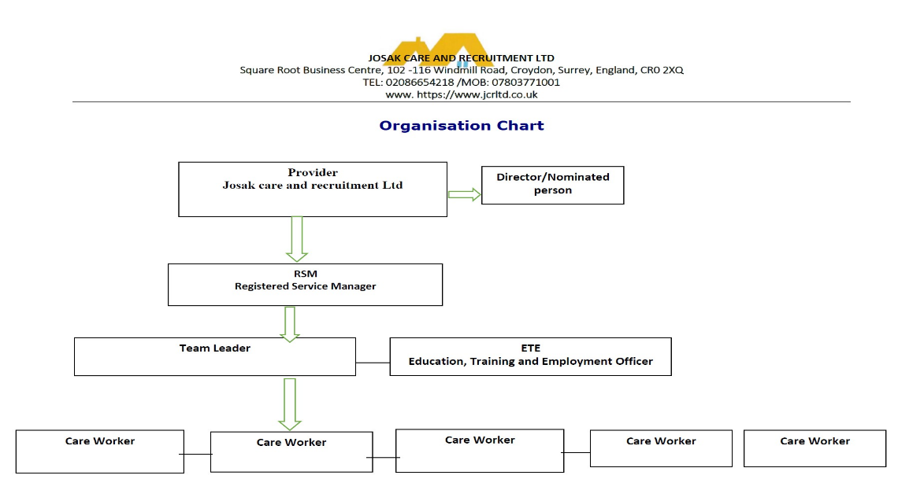
Leadership and management

The Nominated Individual(NI) and Registered Service Manager (RSM) all have over 10 years’ experience supporting children and young people, and possess as a minimum a level 5 qualification. Also, all staff employed by Josak have access to training opportunities and all staff are expected to complete mandatory training and must be registered for an NCFECACHE Level 3 Diploma for Residential Child care in accordance with their role, if they had not already completed one. This is reviewed by the home managers in collaboration with Josak’s HR Department.
Staff are supported both personally and professionally to reach their full potential in performing their role within the supported accommodation, and we very much encourage personal development. Staff are encouraged to enrol for a level 5 leadership and management qualification as soon as they have completed the level 3 diploma. Staff undergo quarterly reviews and a full annual appraisal to ensure that they are achieving any related targets, are best equipped and qualified to do their job, and see if they have any issues or concerns that need to be addressed.
Please refer to our Recruitment and Selection Policy to see our approach to recruiting adequately and appropriately trained staff.
Care planning
When a young person comes to live in one of our supported accommodations, we rely on the social worker’s placement referral form, so we can best assess their continuing needs. We have an admissions policy which allows anyone who comes to live with us, to be placed appropriately, sensitively, and planned so as not to disrupt that young people’s day-to-day life too much. We know that it will be a naturally upsetting and distressing time for them, so our priority is to welcome them to us as fully prepared as possible. They may be undergoing an unpleasant period of unrest, they may be confused and scared. We want to alleviate those fears and let them know it is a warm, welcoming and stable family home they are entering, where they matter, their opinion matters, and we want to do all that we can to help them.
The supported accommodation follows a process of admission in line with the schedules set out in The Care Planning, Placement and Case Review (England) (Amendment) Regulations 2021. Each and every young people who comes to live at our supported accommodation has a detailed and comprehensive care planning pathway, tailored to their specific needs and aspirations. This is done with a collaboration of effort from everyone who is involved in their care, including the young people. The care plan will act as the crux of the young people’s stay and will include all aspects of their life, from schooling, and behavioural difficulties, medication needed, their interests and hobbies, health and social needs, etc.
Care plans provide a direct approach to very individualised care and support for that young people. It is a means of communication and of demonstrating that everyone involved is on the same page; the key factor is to allow the young people to be supported to live a positive life and to measure the effectiveness of working towards that outcome.
Quality assurance and monitoring
We use an external consultant to carry out a mini mock inspection in line with the new Ofsted regulation, the SAR(Self-Assessment Report) produced is used to measure how well we are performing as an organisation.
We carry out this exercise because quality assurance is a designated requirement and a system of quality control which has been set up to encompass all areas of our supported accommodation. This enhances not only the young people’s individual care, support and welfare needs but that of the staff and any visitors to the supported accommodation.
Quality Assurance audits are systematically carried out to monitor, assess and evaluate whether the systems in place are being implemented and are effective. The audits highlight any concerns or, improvements, which are then put into practice to further augment our services and future progression.

